**Active Directory Integration**

**Active Directory Integration:**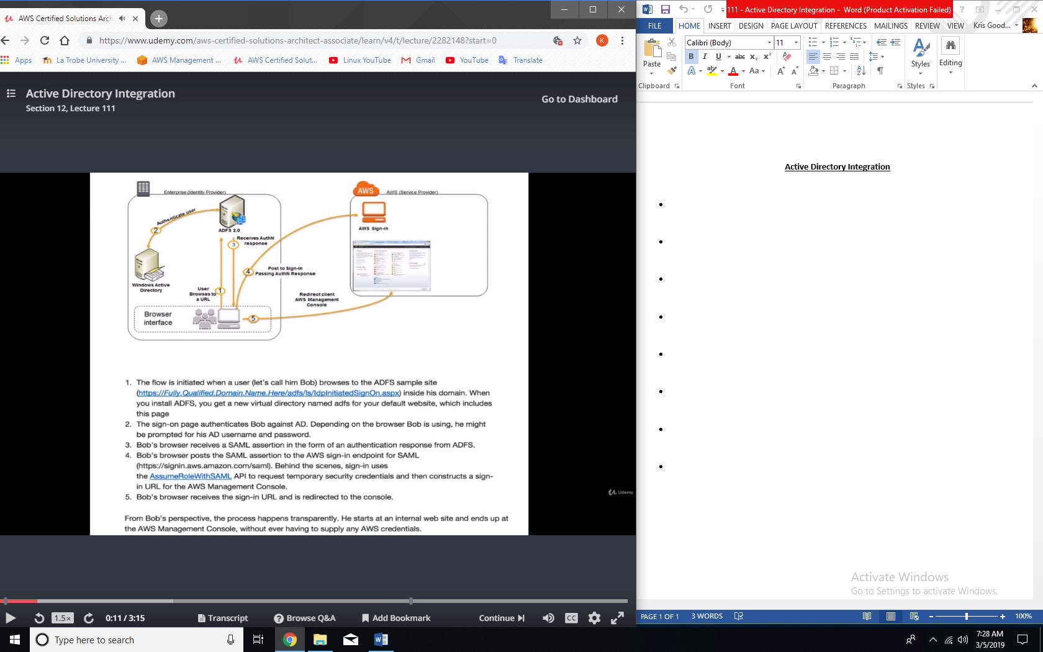

**Can you authenticate with Active Directory?**

* Yes, using SAML.
* Always authenticate against Active Directory first then you would be assigned the temporary security credential.